
Symbiosis Institute of Technology, Pune
Faculty of Engineering
CSE- Academic Year 2026-27
Java Programming – Lab Batch 2024-28
Lab Assignment No:- 15
Name of Student | Aarushi Raizada
PRN No. | 25070122002
Batch | 2025-29
Class | A1
Academic Year & Semester | 2026 Sem III
Date of Submission | 24th August’26
Title of Assignment: | Write a Java program to demonstrate exception handling using finally, throw, and throws.
Theory  Practice questions | The finally block always executes regardless of whether an exception occurs, making it suitable for resource cleanup. The throw keyword explicitly generates an exception, while throws declares exceptions that a method may pass to its caller. These mechanisms improve structured error handling and application stability.  1. Create a Login program that throws an exception for invalid password and uses finally block.  import java.util.Scanner;  public class throwsex {  static void login(String password) throws Exception {  if (!password.equals("1234")) {  throw new Exception("Invalid Password");  }  System.out.println("Login Successful");  }  public static void main(String[] args) {  Scanner sc = new Scanner(System.in);  try {  System.out.print("Enter password: ");  String password = sc.nextLine();  login(password);  }  catch (Exception e) {  System.out.println(e.getMessage());  }  finally {  System.out.println("Login process completed");  }  }  }  2. Create an ATM PIN Verification program that throws an exception for an invalid PIN entered by the user and uses a finally block to display a message indicating that the verification process has completed.  import java.util.Scanner;  public class throwsex2 {  static void verifyPIN(int pin) throws Exception {  if (pin != 1234) {  throw new Exception("Invalid PIN");  }  System.out.println("PIN Verified");  }  public static void main(String[] args) {  Scanner sc = new Scanner(System.in);  try {  System.out.print("Enter PIN: ");  int pin = sc.nextInt();  verifyPIN(pin);  }  catch (Exception e) {  System.out.println(e.getMessage());  }  finally {  System.out.println("PIN verification completed");  }  }  }
Output Screenshots (if applicable) | Ans 1  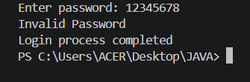  Ans 2  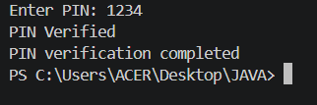
Conclusion

